A154-Eur-Czech Republic-Dolní Věstonice-Figurine-Anthropomorphic-Female-Ceramic-29,000–22,000 BP

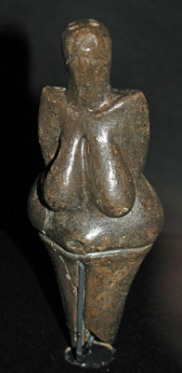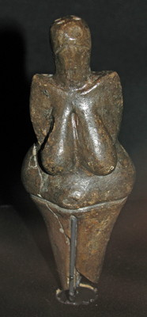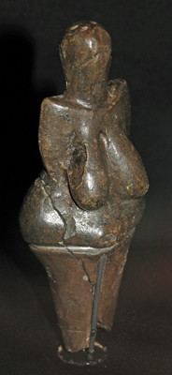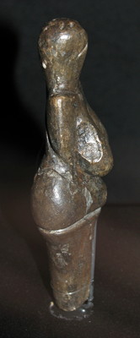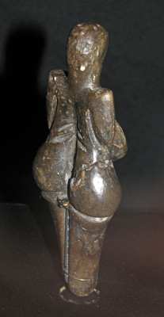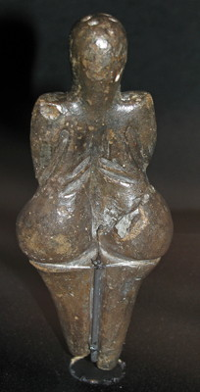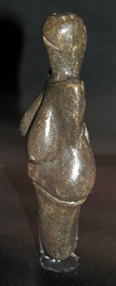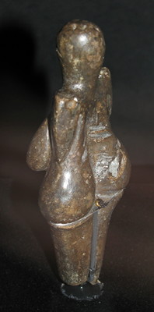

Figs. 1-8. Czech Republic-Dolní Věstonice-Figurine-Anthropomorphic-Female-Ceramic-29,000–22,000 BP  
From <http://www.donsmaps.com/dolnivenus.html>. Photos taken by Don Hitchcock at the Naturhistoriches Museum in Vienna in 2008 when the “Venus” of Dolní Věstonice was on loan from the Anthroposmuseum in Brno, Czech Republic.

**Case No.: 1**

**Accession Number:** A154

**Formal Label:** Czech Republic-Dolní Věstonice-Figurine-Anthropomorphic-Female-Ceramic-29,000–22,000 BP  
**Display Description:** The Paleolithic settlement of Dolní Věstonice in Moravia, Czech Republic, has been excavated since 1924, when it was initiated by Karel Absolon (June 16, 1877 – October 6, 1960). This site has been a source of over 10,000 fragmentary ceramic figurines that were fired at a low temperature, 1300o F or 700 o C during the Gravettian period (29,000-22,000 BP). The question remains, why were these figurines allowed to fracture in the kiln and why was no pottery produced at this site?

**LC Classification:** GN772.22.C95

**Date or Time Horizon:** 29,000-22,000 BP

**Geographical Area:** Moravia in the Czech Republic, on the hill of Pollau.

**Map, GPS Coodinates**: 48.88822 16.64369, 40° 26' 46" N 79° 58' 56" W

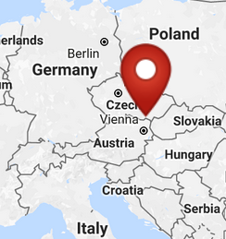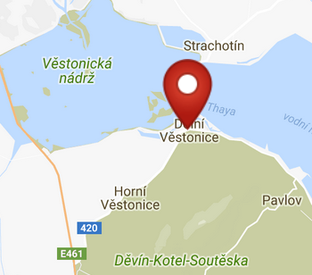

Fig. 9-10. Maps of the location of Dolní Věstonice from <http://latitude.to/img/latitude-logo.svg>.

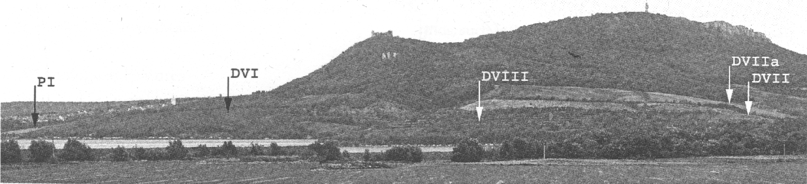

Fig. 11. Pavloski Hills showing profile of where sites are located. Photo by M. Novak. (Trinkaus and Svoboda 2005: Fig. 3.2)

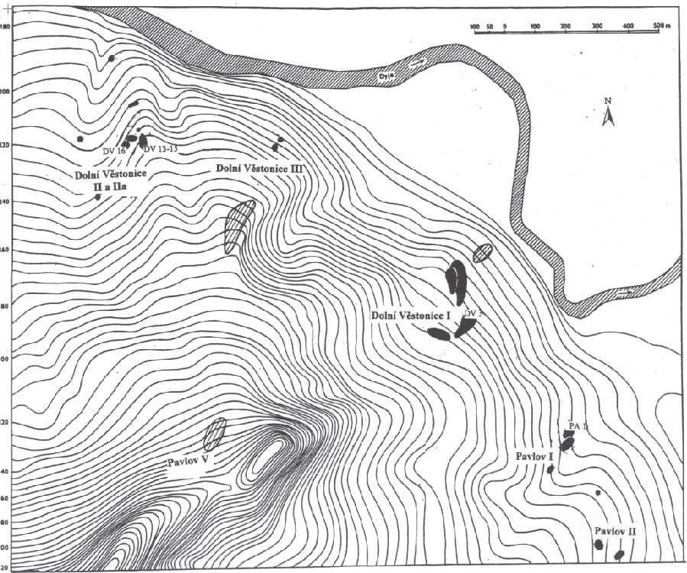

Fig. 12. Map of the location of Dolní Věstonice where sites are located and where burials marked DV are located and where Pavlov sites and burials marked PA are located (Trinkaus and Svoboda 2005: Fig. 3.1).

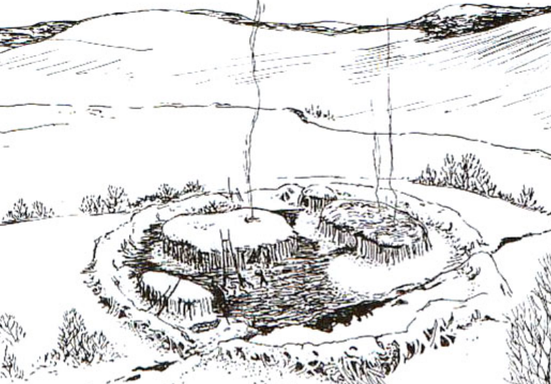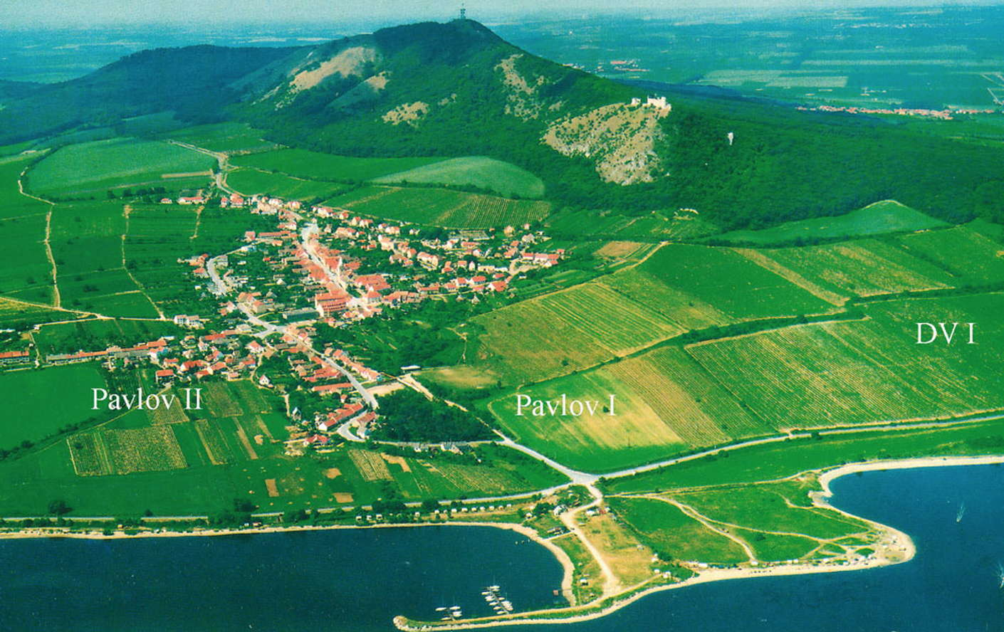

Fig. 13. Artist’s reconstruction of huts within enclosure wall at Dolní Věstonice, Moravia, Czech Republic, 29,000 BP, after <http://humanpast.net/images/dolni.JPG>.

Fig. 14. Aerial view of Dolní Věstonice, Moravia, Czech Republic, 2004, after Svoboda (2007)

**Cultural Affiliation:** Gravettian period

**Medium:** ceramic.

**Dimensions:**  H 11.1 cm, 4.4 in: W 4.3 cm, 1.7 in.  
**Weight:** original, unknown.

**Provenance:** Anthroposmuseum in Brno, Czech Republic.

**Condition:** museum replica in resin.

**Discussion:**

Dolní Věstonice, Moravia, Czech Republic, is located on Pollau Hill, 549 m (1,801 ft) asl, and dates to the Gravettian period (28,000 BP-24,000 BP). Its uniqueness stems from its ceramic figurines that were fired at fired clay at low temperature, 1300o F or 700 o C and then were allowed to fracture due to thermal shock.

This figurine, which has only one fracture, was discovered on 13 July 1925 in a layer of ash. In 2004 a tomograph scan revealed a fingerprint of a young person estimated at between 7 and 15 years of age (based on the size of the fingerprint) fired into its surface. Coincidentally, the grave of a young woman had been discovered in 1949, and romanticists have speculated that she is the creator of the figurine.

Fig. 15. The top of the head of the Dolní Věstonice “Venus”. Photo: http://www.britishmuseum.org/images/v2/homepage-carousel/ice-age-art.jpg

Note the four depressions in the top of the cranium, which appear too shallow to 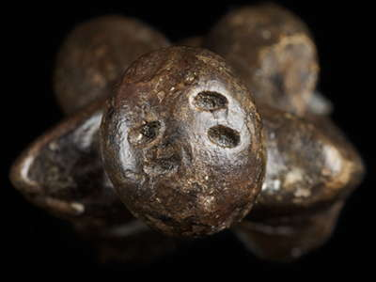hold anything like herbs, or a head covering.

However another explanation of these four 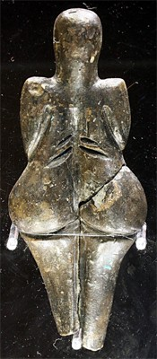oblong shallow depressions may be in order. They may be trepanations (holes cut into the skull) used to release fluid due to meningitis or another brain-case hydrocephaly. In addition, the area just above the sub-vertebral lymph sinus on the back of the figurine also has four oblique “slash” marks. These could be tattoo marks placed there to relieve an ailment like the pain experienced with ruptured thoracic discs or kidney stones or some kidney disease within the sub-vertebral lymph simus. Tattoos similar to these oblique marks were found on the body of the Özti, the “Iceman”.

Fig. 16. Rear view of the Dolní Věstonice “Venus.” Photo: Petr Novák, Wikipedia. This file is licensed under the Creative Commons Attribution-Share Alike 2.5 Generic license.

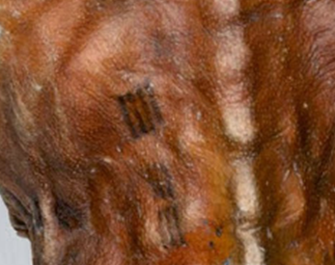

Fig. 17. Ötzi’s ca 3200 BC (5200 BP) lumbar vertebral area tattoos. Credit: S*outh Tyrol Museum of Archaeology*, from https://1.bp.blogspot.com/-IljZsmpaYFs/UnETf7hnafI/AAAAAAAA2rY/DCiE3M2Sofc/s400/Iceman-tattoes_04.jpg.

Radiations from ruptured or distended discs in the lumbar area can be severe. This placement would suggest that Özti’s tattoos were a primitive form of acupuncture. The the Dolní Věstonice “Venus” figurine has similar oblique parallel marks on either side of her vertebral column which would place them about where kidney pain or thoracic disc radiations might occur. It would be remarkable if, at the time horizon of 27,000 BP, such medical knowledge were known and acted upon, since Ötzi’s time horizon is some 22,000 years later!

In addition to this Venus figurine many others have been found – fragmented into 10,000 pieces -- including figurines of Pleistocene animals such as cave bear, saber-toothed tiger, mammoth, horse, fox, rhinoceros and birds, such as owls. However, many of these were found in a shattered state due to ceramic thermal shock created in the kilns. Powers (1994) reported that the ceramicists used yellow clay mixed with powdered burnt mammoth bone which Velde and Druc (2012) indicate that it was used to temper the clay. As bone fragments, which have calcium and phosphorus, are destroyed by heat these elements become a fusing agents. However at the temperatures achieved in their kilns (up to 1,500 °F) the Dolní Věstonice ceramicists were not successful. The question is, if these ceramicists were so experienced at mixing mammoth bone grog with their loess clay why were these figurines *allowed* to become fragmented? Since it appears that it was done *on purpose*, what are the reasons?

In comparative, historical ethnography the nearly unique New Hebridean practice of fragmerntation and enchainment using broken figurines is found in the division of large wooden sculptures (*malanggan*). These sculptures are carved and painted upon the death of local clansmen by ritual specialists with the explicit purpose of providing the deceased with a temporary body during the funeral rites. Only a few selected people are allowed to memorize the symbolism of the intact sculpture during this time after which it is no longer on view to the community and is then destroyed (or sold outside the community), which intentionally brakes its holistic materiality but not its ontological spirituality. Then, through the mnemonic data thus acquired by the chosen few, the memory and the energy of the deceased is continually dispersed in the community as well as the mnemonic data corresponding to a land transaction that was in effect before the death of the clansman (Küchler 1992; 1988). This rite is economic, social and philosophical and in the largest sense of spiritual. There is a wide variety of fragmentation behavior in which the *inalienability* of valued objects is extended to their fragmented parts as well. That is, cumulative fragmentation of fired clay figurines provides a material means whereby social and religious relations can transcend time and space (Ray 1987; for the Neolithic aspects of *pottery* fragmentation see Chapman). Dolní Věstonice figurines were made in the community by ceramic specialists in the community for the community and they carried the symbolism of the community whether whole or fragmented.

Perhaps, the experience of seeing a figurine in a whole condition prior to firing and then shatter in the kiln created a sense that their fragmented state only allows one to remember what they were once whole objects, a memory that can last in eternity. That is, fragmentation allowed their original shape to remain as a memory and not as a complete artifact, much like loved ones who die are remembered as they were and not as they are in death. If this is correct, then Dolní Věstonice fragmented figurines provide *one of the* *first recorded mnemonic spiritualities of ontology in world prehistory*.

**References:**

Chapman, John. 2000. *Fragementation in Archaeology:People, places and broken objects in the pre-history of southeastern Europe*. London and New York: Routledge.

Küchler, S. 1992. “Making skins: malanggan and the idiom of kinship in Northern New Ireland.” In J. Coote and A. Sheldton, eds., *Anthropology, Art, Aesthetics*. Oxford: Clarendon Press.

Küchler, S. 1988. “Malanggan: objects, sacrifice, and the production of memory,” *American Ethnologist*, 15(4): 625-637.

Jelinek, J. 1975. *The Pictorial Encyclopedia of the Evolution of Man*. London: Hamlyn

Powers, R. 1994. "The Human Form in Palaeolithic Art," *Modern Geology*, 19(2-4), Switzerland: Gordon and Breach.

Rau, S., D. Naumann, M. Barth, Y. Mühleis, C. Bleckmann. 2009. *Eiszeit: Kunst und Kultur*. Stuttgart: Thorbecke Verlag der Schwabenverlag AG.

Ray, K. 1987. “Material metaphor, social interaction and historical reconstructions: exploring patterns of association and symbolism in the Igbo-Ukwu corpus.” In I Hodder, ed., *The archaeology of contextual meanings*. Cambridge: Cambridge University Press.

Svoboda, Jiri and Ofer Bar-Yosef. 2003. *Stránská skála : origins of the Upper Paleolithic in the Brno Basin, Moravia, Czech Republic*. Cambridge, MA: Peabody Museum of Archaeology and Ethnology, Harvard University.

Svoboda J. 2007. “The Gravettian on the Middle Danube,” *Paleo,* 19:203-220.

Velde, B. and I. Druc. 2012: *Archaeological Ceramic Materials: Origin and Utilization*. London: Springer.